ICTCLD507 Build and Deploy Resources on Cloud Platforms

ICTCLD508 Manage Infrastructure in Cloud Environments

Version : v1.0  
  
Student Name: Warren Ikin

Student ID: 453470833

Submission Date:24/09/2022

Contents:

Scope 1

Client Details: 1

**Assessment Brief** 5

Scope

To create a -hybrid solution and to move its critical infrastructure to the cloud- reduce its operational costs-provide reliable services-Using services that are validated for Financial Services on the Cloud-Two Virtual Private Clouds (VPCs)- 1.management services-2.actual workloads-Security Groups (SGs)-Access Control Lists (ACLs)- their own private Load Balancer (LB)- VPN connections to remote sites or to the branch office as a backup.

Client Details:

|  |  |
| --- | --- |
| Business Name: | ABC Banking Corp |
| Business Location: | Branch Office, Level 27, 10 Market Street, Brisbane City |
| Date: | 25th September 2022 |
| Analyst Name: | Warren Ikin |
| Information Sources: | The consultant Cloud Architect |

1. Introduction to ABC Banking Corp

It is understood that Uptown IT has been tasked with implementing ABC Banking Corp’s new hybrid solution and to move its critical infrastructure to the cloud as recommended by the consultant cloud architect. The design for the prospective move is due to the significant costs in maintaining a data centre, its staff, and the increasing security risks. By this move, the bank is expecting to reduce its operational costs and to provide reliable services to its customers.

There are hundreds of various solutions and proprietors available and ready to offer the best solution for ABC Banking’s needs. Third party proprietors introducing new and better tools and plugins to augment cloud services every day. The mind boggles with the availability of choice. The challenge is to find the right one. ABC Banking already has considerable resources at hand. These resources already utilize many technologies that need to be migrated to cloud. ABC Banking’s infrastructure is already running on hypervisors and operating virtual systems on the on-premises data center. VPNs already exist between the secret data centre and the central management control center. Perhaps the most economical solution is the one that is easiest to setup and maintain. That being said we at Uptown IT believe the most appropriate solution is to engage more deeply into VMware’s tool set and jockey AWS’s considerable resources and economy of scale. This way we don’t have to reinvent the wheel. The ABC Bank’s migration to the cloud can be eased into the evolution of the technological landscape. Furthermore, the possibilities for high availability and security are endless if VMware architecture is replicated across various providers like Azure or Google as well as AWS.

The combination of VMware and AWS extends your hybrid cloud in a manner that it would not be able to scale otherwise. VMware is a market-leading hybrid cloud capability and services that extend your data center virtualization capability. It also has simple and consistent operations for IT. In other words, your team does not have to learn significant new technical capabilities to use the VMware Cloud on AWS. It has full enterprise scale for your hybrid cloud. It also is fully operated and supported directly by VMware. This allows your organization to go directly to VMware and not have to put in separate calls for AWS and VMware. This is all handled by VMware. This would also be known as a one-stop shop for support. VMware on AWS has global scale. Essentially, you're able to use regions and availability zones in the AWS configurations. It has seamless bidirectional application portability and migration services. You also have the capability to use a service on demand or as a service subscription. You have flexibility on how you want to provision the services. Your existing team members can also have a minimal learning curve.

Hybrid deployment will allow ABC Banking to extend and scale their infrastructure into the cloud while still maintaining access to on-premises resources living on on-site servers. We can use the cloud deployment as backup in disaster recovery solution or vice versa. ABC Banking can maintain a working copy on premises, but make sure they have durable backup in the cloud. Because migration of existing IT systems take a long time and is costly, hybrid deployment is a very effective in-between as resources are migrated to the cloud

2. Functionalities and resources that can be deployed in Cloud

Organizations of every type, size, and industry are using the cloud for a wide variety of use cases, such as data backup, disaster recovery, email, virtual desktops, software development and testing, big data analytics, and customer-facing web applications. The major advantages of the cloud over on-premises:

* Agility - The cloud gives you easy access to a broad range of technologies so that you can innovate faster and build nearly anything that you can imagine. You can quickly spin up resources as you need them–from infrastructure services, such as compute, storage, and databases, to machine learning, data lakes and analytics, and much more.
* Elasticity - With cloud computing, you don’t have to over-provision resources up front to handle peak levels of business activity in the future. Instead, you provision the amount of resources that you actually need. You can scale these resources up or down to instantly grow and shrink capacity as your business needs change.
* Cost savings - The cloud allows you to trade fixed expenses (such as data centers and physical servers) for variable expenses, and only pay for IT as you consume it. Plus, the variable expenses are much lower than what you would pay to do it yourself because of the economies of scale.
* Deploy globally in minutes - With the cloud, you can expand to new geographic regions and deploy globally in minutes. For example, AWS has infrastructure all over the world, so you can deploy your services in multiple physical locations with just a few clicks.

There are three main cloud computing models. Software as a service or SaaS, platform as a service or PaaS, and infrastructure as a service or IaaS. Given the ABC Bank’s current infrastructure Uptown IT proposes we use VMware Cloud on AWS’s bare metal IaaS platform. We can use vSphere and NSX to securely manage resources from anywhere that has internet service.

* Infrastructure as a service also known as IaaS refers to the basic building blocks of cloud IT infrastructure. You have control over the networking, security, computer, and servers. IaaS provides the most flexibility and management control of all the different types of cloud computing models, and it's the closest in features to having the traditional on-premises data center. Some examples of infrastructure as a service platforms are Amazon Web Services, Microsoft Azure, and Google Cloud. You can modify and control almost all parts of the infrastructure in the cloud to fit your needs without having to purchase or manage actual hardware.
* Platform as a service known as PaaS allows you to deploy and manage applications without worrying about the underlying hardware infrastructure. Services offered could be web servers, databases, operating systems, or environments where you can execute specific programming languages to host applications. Some examples of PaaS are Microsoft Azure web hosting, Google App Engine, and Heroku. You can focus on deploying the applications instead of the operational side of deployment. PaaS is different from IaaS in that there is less flexibility as packages are preconstructed. But, you also have to deal with less of the infrastructure deployment and maintenance allowing you more time and resources to focus on the project at hand as opposed to the infrastructure.
* Software as a service, SaaS, describes completed products managed by the service provider. You get the whole package of the service complete with user interfaces. It's ready for use by an end user regardless of their technical backgrounds. You don't have to worry about how the service infrastructure is maintained or managed. You only have to worry about how you might use the service to fulfill a need. In terms of complexity and level of involvement required, infrastructure as a service is the most involved and requires the highest level of technical knowledge to execute, followed by platform as a service. Software as a service generally does not require much technical knowledge and it's extremely intuitive and features are ready to use quote unquote out of the box.

**Assessment Brief**

ABC Banking Corp. is a leading financial organization operating in Australia for more than 40 years. It has branch offices in all major cities in Australia as well as in remote cities across most states. Currently the companies’ main data centre is in an undisclosed site in Brisbane and is operated by its IT staff located on-site and in the Brisbane branch office.  
Due to the significant costs in maintaining a data centre, its staff and the increasing security risks, ABC Banking Corp. is looking at a hybrid solution and to move its critical infrastructure to the cloud, by this move, the bank is expecting to reduce its operational costs and to provide reliable services to its customers. The bank has hired a consultant cloud architect to recommend an initial design for the prospective move.  
The consultant Cloud Architect, after studying the requirements of the bank has come up with the following architecture.

**Proposed Architecture**

The architecture is built by using services that are validated for Financial Services on the Cloud. The combined configuration of these services will implement the following principles:

* Layered security: To prevent the compromise of a service from a single point of attack, the Cloud infrastructure must provide multiple redundant layers of security. VPC
* Least privileges: no individual should be given enough privileges to misuse a system. Give people the minimum required authorizations to complete their activities. IAM
* Data privacy: protect data from unauthorized disclosure, modification, and destruction. EBS
* Security assurance: controls must be configured securely by default through automation and checked continuously for compliance to provide continued controls assurance. CloudWatch
* Auditing: enable traceability through the logging, monitoring, alerting, and collection of audit information in real time. AWS-CLI
* Resilience: availability of services and data are critical to the operation of business applications. Incorporate multiple levels of resilience to maintain cloud services even after multiple component failures. ELB
* Integrity: follow secure development and operations processes and ensure software integrity through automation. IAM

The following diagram shows the proposed architecture that incorporates the above principles. It includes two Virtual Private Clouds (VPCs), one for the management services and the other for the actual workloads. The virtual servers within the VPCs are secured by their own Security Groups (SGs) and the Access Control Lists (ACLs) of the subnet. Each VPCs have their own private Load Balancer (LB) and are directly linked to the branch offices. They also support VPN connections to remote sites or to the branch office as a backup.

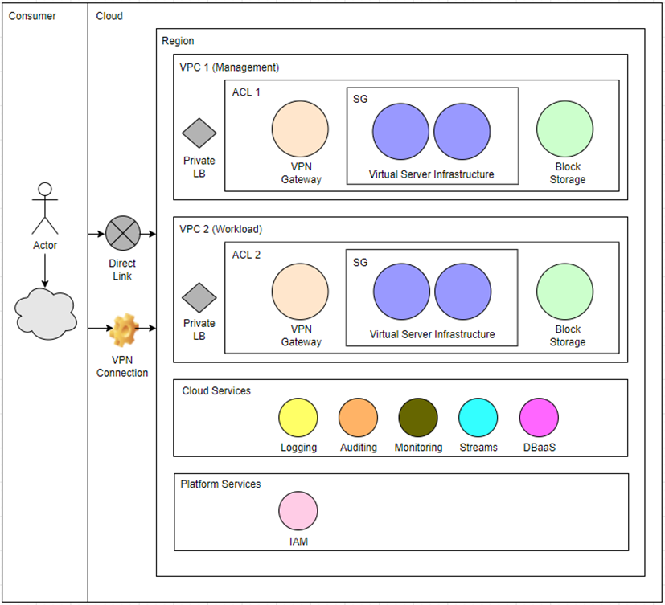

|  |
| --- |
| 1. Given an introduction to ABC Banking Corp |
| 1. Explained the functionalities and resources that can be deployed in Cloud |
| 1. Explained the Cloud computing resources required |
| 1. Explained the capacity Limits of the resources |
| 1. Described what Organisational policies are implemented in cloud |
| 1. Completed the table with Business Purpose and required cloud resources |
| 1. Explained the repeatable tasks and the tools used automate these tasks |
| 1. Listed the steps required to provision resources |
| 1. Explained how the resources that you provision in your infrastructure model are tested |
| 1. Written at least two policies for each of the following:   tagging policy and categorise cloud resources  configuration policy for cloud resources  data retention policy in cloud environment |

Non-functional requirements

The consultant Cloud Architect has identified the following non-functional requirements for ABC Banking Corp.

Security

*All application systems must implement robust controls over their communication network for these purposes:*

Safeguarding data

Tightly controlling access to network devices through management approval and subsequent audits

Disabling remote communications when no business need exists

Logging and monitoring remote access

Securing remote access devices

Using strong authentication and encryption to secure communications

*All confidential bank data must be encrypted while in transit on any network or stored on any device on premises, or on a private or public cloud. Confidential bank information, including authentication credentials, must be encrypted while in transit over any public network or wireless network. Key management procedures must be employed that assure the confidentiality, integrity, and availability of cryptographic key material. The use of encryption products must comply with local restrictions and regulations in the relevant country.*

Scalability

*The architecture must be able to support more than hundred thousand customers, over a million transactions per day, and manage assets of more than USD 4 billion. The architecture must not only meet the current requirements but also anticipate the future needs of a dynamic, growth-focused institution. The infrastructure must boost the business, not limit it. It must provide a demonstrated ability to scale and align to the business objectives as the financial institution grows.*

Availability

*ABC Banking Corp. need to operate in a 24 x 7 environment. The infrastructure must be available to the customers whenever they want, wherever they are, and on whatever channel they prefer to interact. Mission-critical applications such as payment processing and other core banking transaction processing require 99.99% availability.*

Performance and response times

*Some of the application components need a high throughput, low-latency, real-time performance. Examples include card authorizations and transactions, payment transactions, fraud detection, and securities processing.*

Business continuity and disaster recovery

*Application systems must have formal documented recovery plans and tools to identify the resources and specify actions that are required to minimize losses if a disruption occurs to the business unit, its supporting group units, applications, or infrastructure components.*

Backup and offsite storage

*All application systems must have a defined backup policy and associated procedures for backing up data in a scheduled and timely manner. Effective controls must be established to safeguard backed-up data onsite and offsite. They must also ensure that the bank data is securely transferred or transported to and from backup locations and conduct periodic tests to ensure that data can be safely recovered from backup devices.*

Your Role

*As a Senior System Administrator with ABC Banking Corp, Management has requested you prepare a project proposal for the new Cloud solution based on the proposed architecture. Please note that the cloud infrastructure will hold all the critical application and database servers. The existing data center will be used as a warm site with daily data synchronization with the cloud systems.*

Further Instructions to Students

*You are required to use the template provided to write the project proposal. The template has all the instructions and guidelines in red fonts to prepare the proposal. These guidelines (all the red text) must be deleted before submitting the document. The template has the following headings.*

3. Cloud computing resources required

4. Capacity Limits of the resources

5. Implement Organisational policies in cloud

6. Business Purpose and required cloud resources

7. Tools used for performing repeatable automated tasks – System backups, daily reports, Elastic load balancing, security patches. EC2 scheduled task using CloudWatch or Lambda functions.

8. Steps required to provision resources – Cloud Formation- devise infrastructure model, then make template using JSON. Put in S3 bucket. Use CloudFormation with template.

9. Test Cloud infrastructure

10. New Policies to be implemented – Policy for resources

Marking Criteria

1. Given an introduction to ABC Banking Corp
2. Explained the functionalities and resources that can be deployed in Cloud
3. Explained the Cloud computing resources required
4. Explained the capacity Limits of the resources
5. Described what Organisational policies are implemented in cloud
6. Completed the table with Business Purpose and required cloud resources
7. Explained the repeatable tasks and the tools used automate these tasks
8. Listed the steps required to provision resources
9. Explained how the resources that you provision in your infrastructure model are tested
10. Written at least two policies for each of the following:
    1. tagging policy and categorise cloud resources
    2. configuration policy for cloud resources
    3. data retention policy in cloud environment

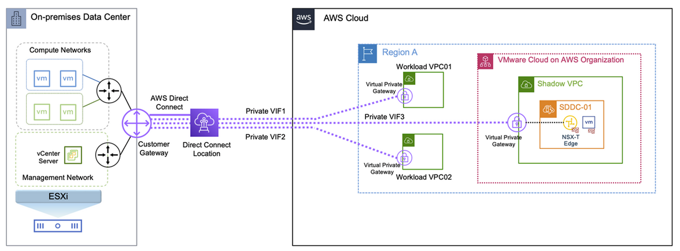<https://aws.amazon.com/blogs/apn/vmware-cloud-on-aws-hybrid-network-design-patterns/>



